Product Roadmap VSOC – Vehicle Security Operations Center

Table of Contents
Product Vision 2
Product Strategy 2
MVP Definition 4
Product Scope 4
Product Capabilities 5
Epics and Features 5
VSOC Phased Release Plan (2025 & 2026) 8
Major Milestones with Dates 8
Proposed Product Roadmap 8
Proposed Feature Roadmap 9
Timeline (Gantt-style) 10

Product Name: VSOC – Vehicle Security Operations Center
Product Owner: Priya
Product Type: SaaS Platform (Cloud-based Cybersecurity)

Product Vision
Vision Statement
To build the industry's leading cloud-native Vehicle Security Operations Center (VSOC) that enables fleet operators and automotive manufacturers to proactively detect, investigate, and respond to cybersecurity threats across connected and autonomous vehicles in real time while ensuring regulatory compliance and operational resilience.
Vision Objectives
- Deliver continuous security monitoring for connected vehicle fleets.
- Enable rapid detection and response to cyber threats.
- Improve operational visibility through centralized dashboards.
- Support compliance with global automotive cybersecurity standards.
- Build a scalable SaaS platform capable of supporting global fleet operations.

Product Strategy
The VSOC product strategy focuses on delivering business value through four strategic pillars.
Strategic Pillar | Description | Success Measure
Real-Time Security Monitoring | Build a cloud-native platform capable of ingesting and analyzing streaming telemetry from connected vehicles. | Telemetry processed within 1 second with 99.9% availability.
Intelligent Threat Detection | Use rule-based detection and AI-assisted analytics to identify anomalies and cyber threats. | Detect over 90% of known threats with a low false-positive rate.
Automated Incident Response | Reduce response time by automatically triggering predefined mitigation actions for critical threats. | Mean Time to Respond (MTTR) under 5 minutes for supported incidents.
Compliance & Reporting | Provide audit-ready reports and secure data management aligned with automotive cybersecurity regulations. | Generate compliance reports on demand with complete audit trails.

Product Goals & KPIs
Goal | KPI | Target
Improve threat detection speed | Mean Time to Detect (MTTD) | Less than 30 seconds
Accelerate incident response | Mean Time to Respond (MTTR) | Less than 5 minutes
Increase platform reliability | System Availability | 99.9% uptime
Improve detection quality | Threat Detection Accuracy | Greater than 90%
Reduce false positives | False Positive Rate | Less than 5%
Improve analyst productivity | Incident Investigation Time | Reduce by 40%
Ensure regulatory compliance | Audit Report Generation | 100% successful report generation
Expand customer adoption | Enterprise Fleet Customers | Onboard 3 customers within first year

Product Principles
The following principles guide all product decisions throughout the VSOC lifecycle.
Security by Design: Security requirements are incorporated into every phase of product development.
Customer-Centric: Features are prioritized based on customer value and operational needs.
Cloud Native: Leverage scalable cloud architecture to support growing fleet sizes.
Privacy First: Protect customer and vehicle data using encryption, secure authentication, and least privilege access.
Compliance by Default: Design processes and reporting to meet automotive cybersecurity and privacy regulations.
Scalability: Support thousands of fleets and millions of connected vehicles without compromising performance.
Automation First: Automate repetitive operational tasks to improve analyst efficiency and reduce response times.

Product Positioning
Item | Description
Product Name | Vehicle Security Operations Center (VSOC)
Product Type | Cloud-based SaaS Platform
Target Market | Automotive OEMs, Fleet Operators, Logistics Companies, Mobility-as-a-Service Providers
Primary Users | Security Analysts, Fleet Operations Teams, Compliance Officers, DevOps Engineers
Problem Solved | Lack of centralized cybersecurity monitoring and response for connected vehicles
Unique Value Proposition | Real-time vehicle security monitoring, automated threat response, and compliance reporting from a single platform
Competitive Differentiators | Cloud-native architecture, AI-assisted threat detection, automated incident response, compliance-ready reporting

Positioning Statement
For organizations managing connected and autonomous vehicle fleets, VSOC is a cloud-native cybersecurity platform that continuously monitors fleet activity, detects cyber threats in real time, automates incident response, and simplifies regulatory compliance through centralized reporting and secure audit trails.

MVP Definition
The Minimum Viable Product (MVP) focuses on delivering core capabilities that provide immediate value to customers.

Included in MVP
- Vehicle registration and onboarding
- Fleet management dashboard
- Real-time telemetry ingestion
- Security monitoring dashboard
- Rule-based threat detection
- Alert generation and notifications
- Incident management
- User authentication and role-based access control
- Basic reporting

Excluded from MVP
- AI-powered threat prediction
- Automated response workflows
- Third-party SIEM integrations
- Compliance dashboard
- Advanced analytics
- Mobile application

Product Scope
In Scope
- Vehicle telemetry ingestion
- Fleet management dashboard
- Threat detection engine
- Security alerts
- Incident management
- Technical reporting
- Executive dashboards
- Audit logging
- Role-based access control
- Cloud deployment
- REST APIs

Out of Scope
- Vehicle hardware development
- Autonomous driving software
- Vehicle firmware updates
- OTA software deployment
- Manufacturing systems
- Physical vehicle security

Product Capabilities
Capability | Description
Fleet Management | Register, organize, and monitor connected vehicle fleets.
Telemetry Processing | Collect and process streaming telemetry data from connected vehicles.
Threat Detection | Detect abnormal vehicle behavior and cybersecurity threats.
Incident Management | Create, assign, investigate, and resolve security incidents.
Automated Response | Execute predefined response actions for critical threats.
Reporting & Analytics | Generate operational, executive, and compliance reports.
Compliance Management | Maintain audit logs and support regulatory reporting.
Identity & Access Management | Secure authentication with role-based permissions.
Platform Administration | Configure users, alerts, integrations, and system settings.

Epics and Features
- Real-Time Vehicle Data Monitoring

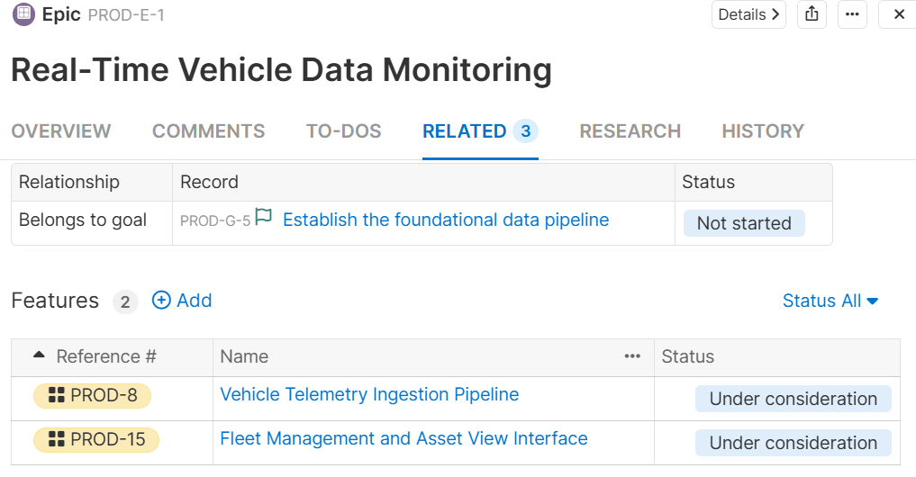

- Threat Detection & Alerting

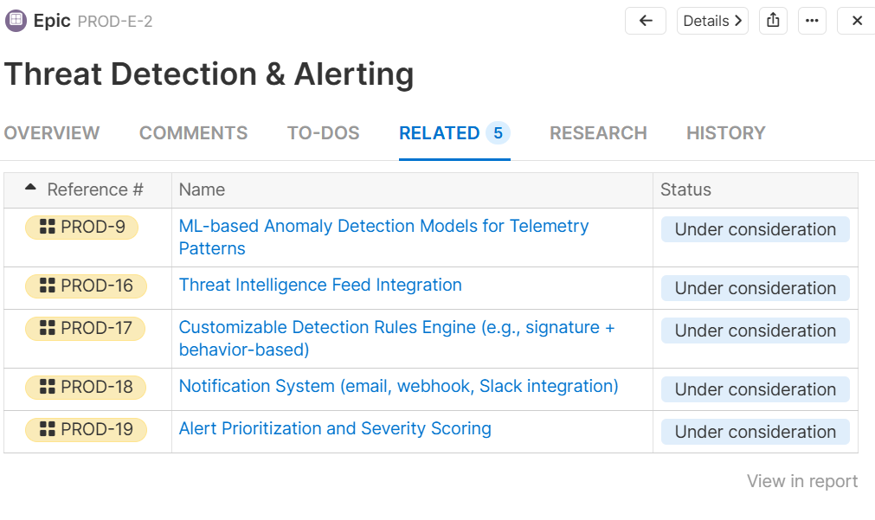
- Automated Threat Response

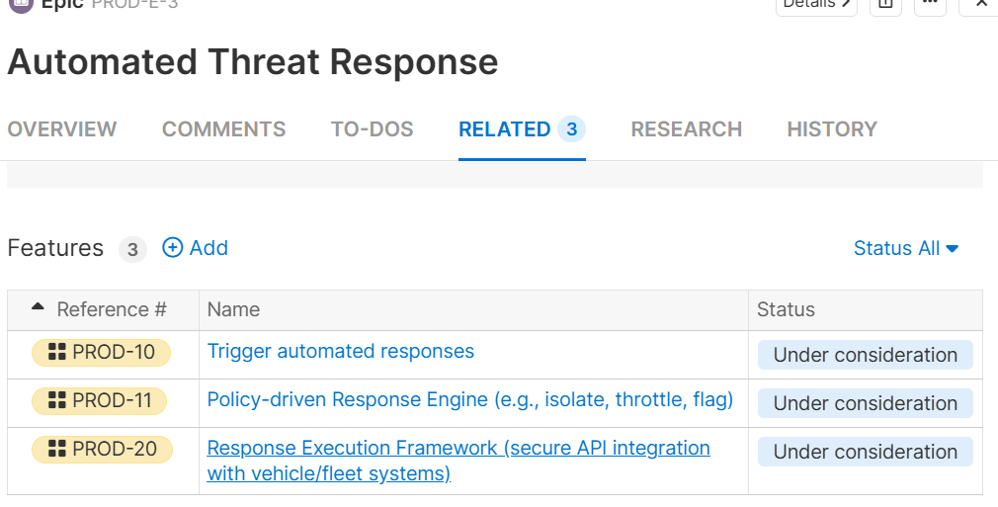
- Reporting & Analytics
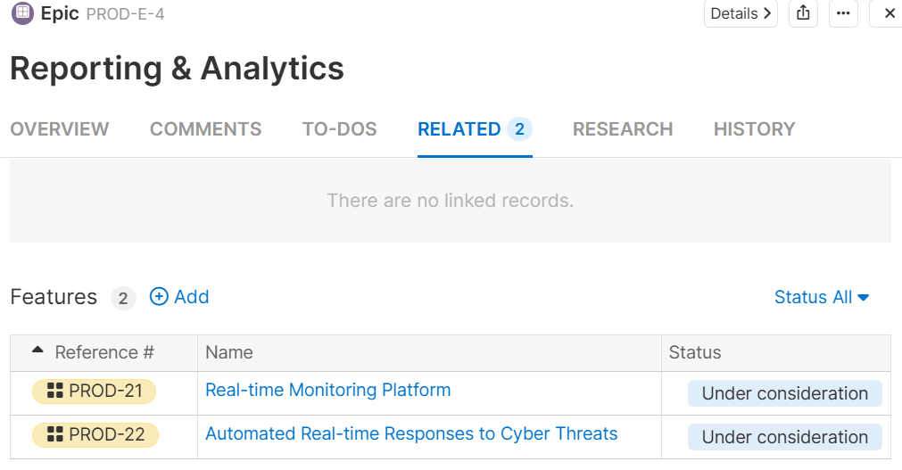

- Compliance & Data Governance

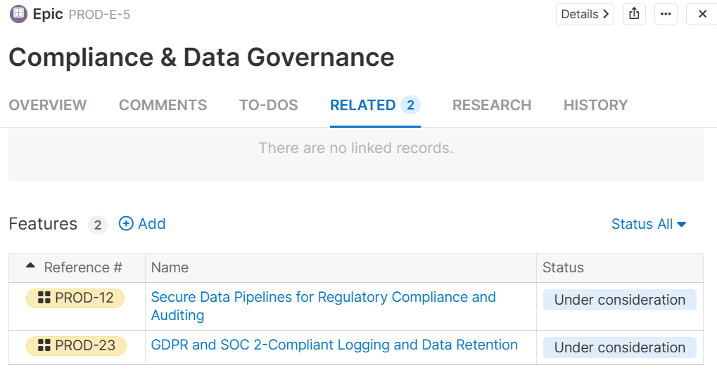

- Platform Infrastructure & Scalability

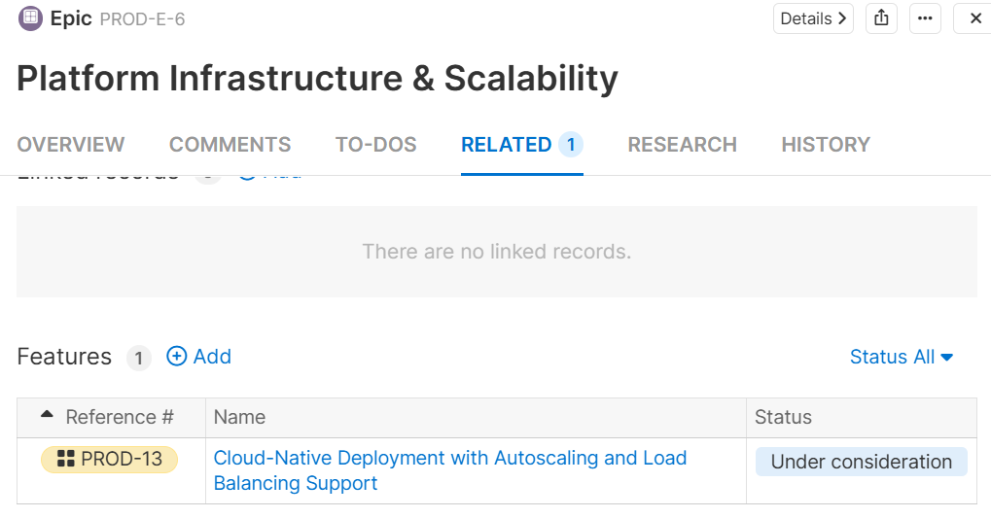

- Integration & Ecosystem

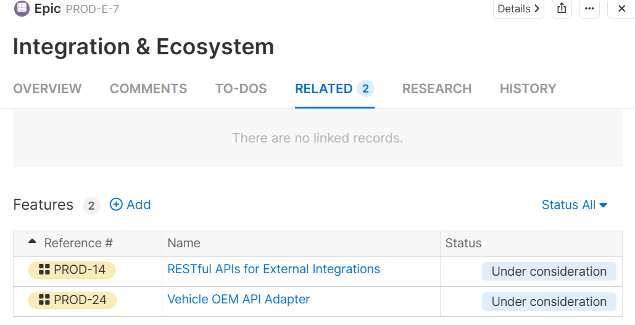

VSOC Phased Release Plan (2025 & 2026)
Phase | Start Date | End Date (Release Date) | Duration | Key Objectives
MVP | Jul 30, 2025 | Nov 28, 2025 | 12 weeks | Core monitoring, data pipeline, dashboard v1
Phase 1 | Dec 1, 2025 | Feb 27, 2026 | 12 weeks | Threat detection, alerting engine, manual response
Phase 2 | Mar 2, 2026 | Jun 30, 2026 | 12 weeks | Auto-response, advanced reporting, correlation
Phase 3 | Jul 1, 2026 | Sep 23, 2026 | 12 weeks | Compliance, scalability, integrations

Major Milestones with Dates
Milestone | Date | Notes
MVP Internal Demo | Nov 10, 2025 | Basic telemetry + alerts
Pilot Fleet Onboarding | Nov 18, 2025 | MVP functionality live with beta customers
Threat Detection Go-Live | Feb 23, 2026 | Full alerting system operational
Auto-Response Engine Deployed | Jun 24, 2026 | Tested with real fleet data
Compliance & Audit Dashboard Preview | Aug 21, 2026 | Includes SOC 2 and GDPR elements
VSOC General Availability (GA) | Sep 18, 2026 | Full commercial launch

Proposed Product Roadmap
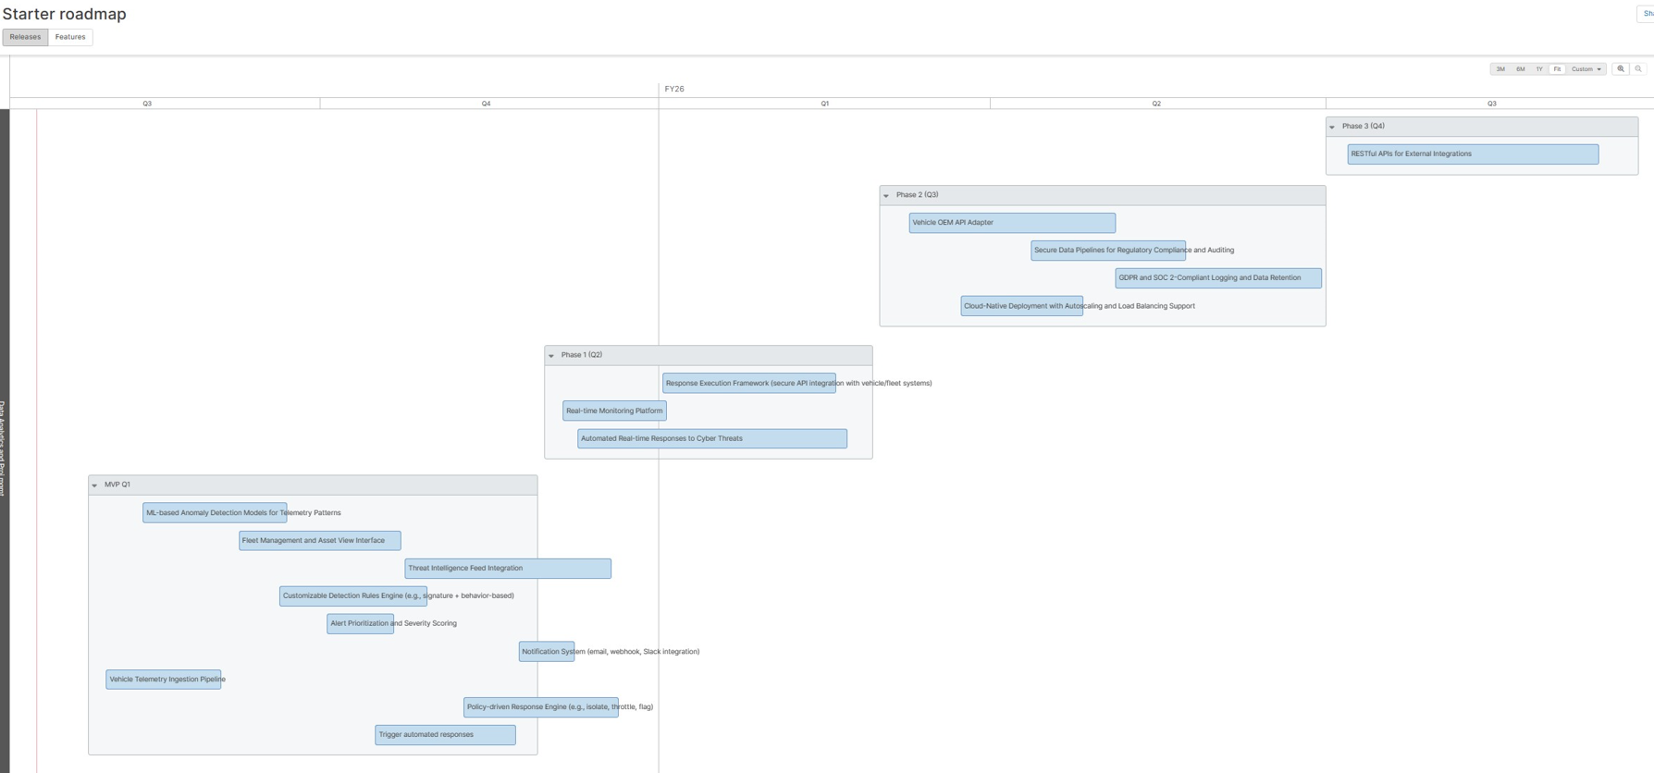
Epic Board
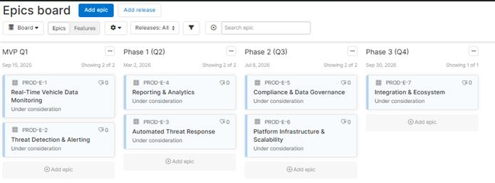

Proposed Feature Roadmap
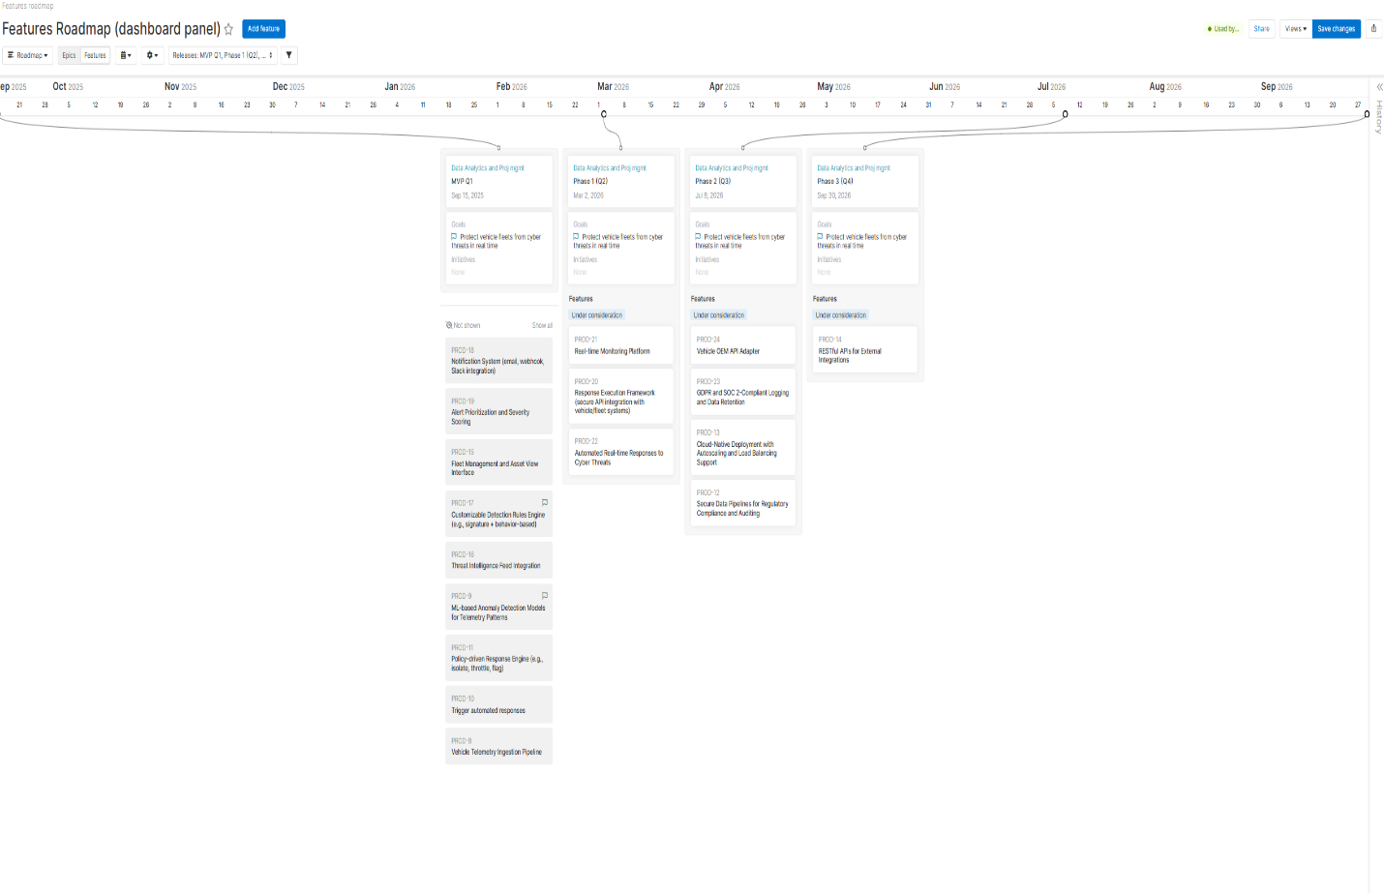

Feature Board
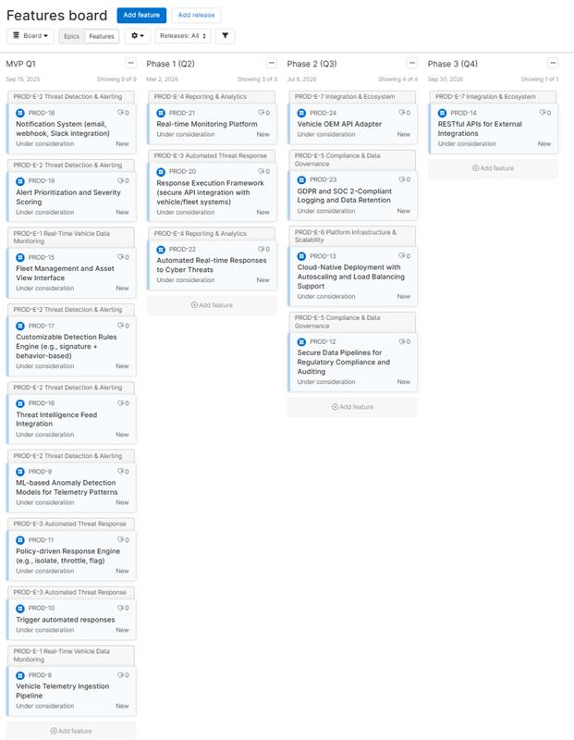

Timeline (Gantt-style)
Note: Green dots are milestone for phase wise release.
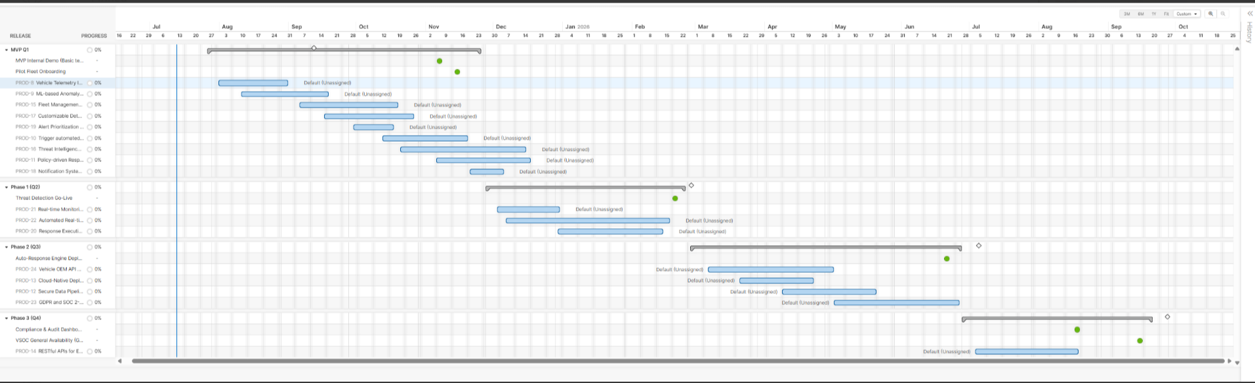

Prioritization Framework
Use MoSCoW.

Must Have | Should Have | Could Have
Telemetry | AI Detection | Predictive AI
Alerts | Reports | Mobile App
Dashboard | Compliance | Chatbot
Authentication | API Integration | Voice Alerts

Product Backlog Summary
Epic | Priority
Vehicle Monitoring | High
Threat Detection | High
Incident Response | High
Reporting | Medium
Compliance | Medium
Integrations | Low

Dependencies
Epic | Depends On
Threat Detection | Telemetry Ingestion
Incident Response | Alert Engine
Reports | Analytics
Compliance | Audit Logs
Fleet Dashboard | Vehicle Registration
Risks & Assumptions
Risks
- High telemetry volume
- Cloud outages
- False positives
- Regulatory changes

Assumptions
- OEM telemetry APIs are available.
- Cloud infrastructure is provisioned.
- Stakeholders provide timely feedback.

Future Roadmap (2028)
- AI Copilot for Analysts
- Threat Prediction
- Digital Twin Security
- OTA Patch Integration
- Mobile App
- SIEM Integrations

